

**REPUBLIC OF CAMEROON**

**Peace-Work-Fatherland**

**MINISTER OF HIGHER EDUCATION**

**FACULTY OF ENGINEERING**

**AND TECHNOLOGY**

**REPUBLIQUE DU CAMEROON**

**PAIX-Travail-Patrie**

**MINISTRE DE L’ENSEIGNEMENT SUPERIEUR**

**FACULTE DE L’ENGINERIE**

**ET TECHGNOLOGIE**

***\*\*\*\*\*\*\*\*\*\*\*\*\*\*\*\*\*\*\**UNIVERSITY OF BUEA *\*\*\*\*\*\*\*\*\*\*\*\*\*\*\*\*\*\*\*\*\*\*\*\*\****

**DEPARTMENT OF COMPUTER ENGINEERING**

**COURSE: INTERNET PROGRAMMING (J2EE) AND MOBILE PROGRAMMING**

**COURSE CODE: CEF 440**

**TASK 6: DATABASE DESIGN AND IMPLEMENTATION**

**PRESENTED BY**

**GROUP 20**

**INSTRUCTOR: DR. VALERY JUNE 2024**

**GROUP MEMBERS**

|  |  |  |
| --- | --- | --- |
| S/N | **Name** | Matricule Number |
| 1 | DUESENBERRY MBIKANG AGBORTAR AKO | FE21A175 |
| 2 | FOTABONG FUALEFAC PUISSANCE | FE21A195 |
| 3 | ABANGMA ARRAH JESUS MCLOUIS | FE21A124 |
| 4 | TABOT JOEL EBANGHA | FE21A308 |
| 5 | EBOMESUMBE NGOLE DANDY BRADLEY | FE21A177 |

Contents

**1. Introduction** 3

**2. Conceptual Design** 3

**Entities Identified:** 3

**Key Relationships and Cardinalities:** 4

**3. Logical Design** 4

**Schema Definition:** 4

**4. Physical Design** 6

**Physical Storage Considerations:** 6

**Database Security Design:** 6

**5. SQL Database Implementation** 6

**SQL Scripts:** 6

**Results:** 7

**6. Technologies Used** 9

• **Database Management System (DBMS):** 9

• **Development Environment:** 9

• **Data Modeling Tools:** 10

• **Testing Tools:** 10

**7. Testing and Validation** 10

**Testing Strategies:** 10

**8. Importance of Database Management in the Disaster Management System** 10

**9. Conclusion** 10

**10. Future Considerations** 10

# **1. Introduction**

In the face of increasing disaster events, both natural and man-made, our team was tasked with the development of a robust disaster management system aimed at mitigating the impact of disasters through enhanced data coordination and response efficiency. This report outlines the database design and implementation phase, which is foundational to the system’s operational success.

# **2. Conceptual Design**

During the conceptual design phase, we developed an Entity-Relationship (ER) Diagram to visualize the data relationships crucial to disaster management:

## **Entities Identified:**

* + **Users**: Individuals using the system, including the general public and disaster victims.
  + **Authority**: Government and agency officials responsible for disaster response.
  + **Respondents**: First responders and emergency services.
  + **Emergency**: Types and details of emergencies.
  + **Contacts**: Contact details for all users.
  + **Alerts, Calls, and Reports**: Communication and data generated during emergencies.

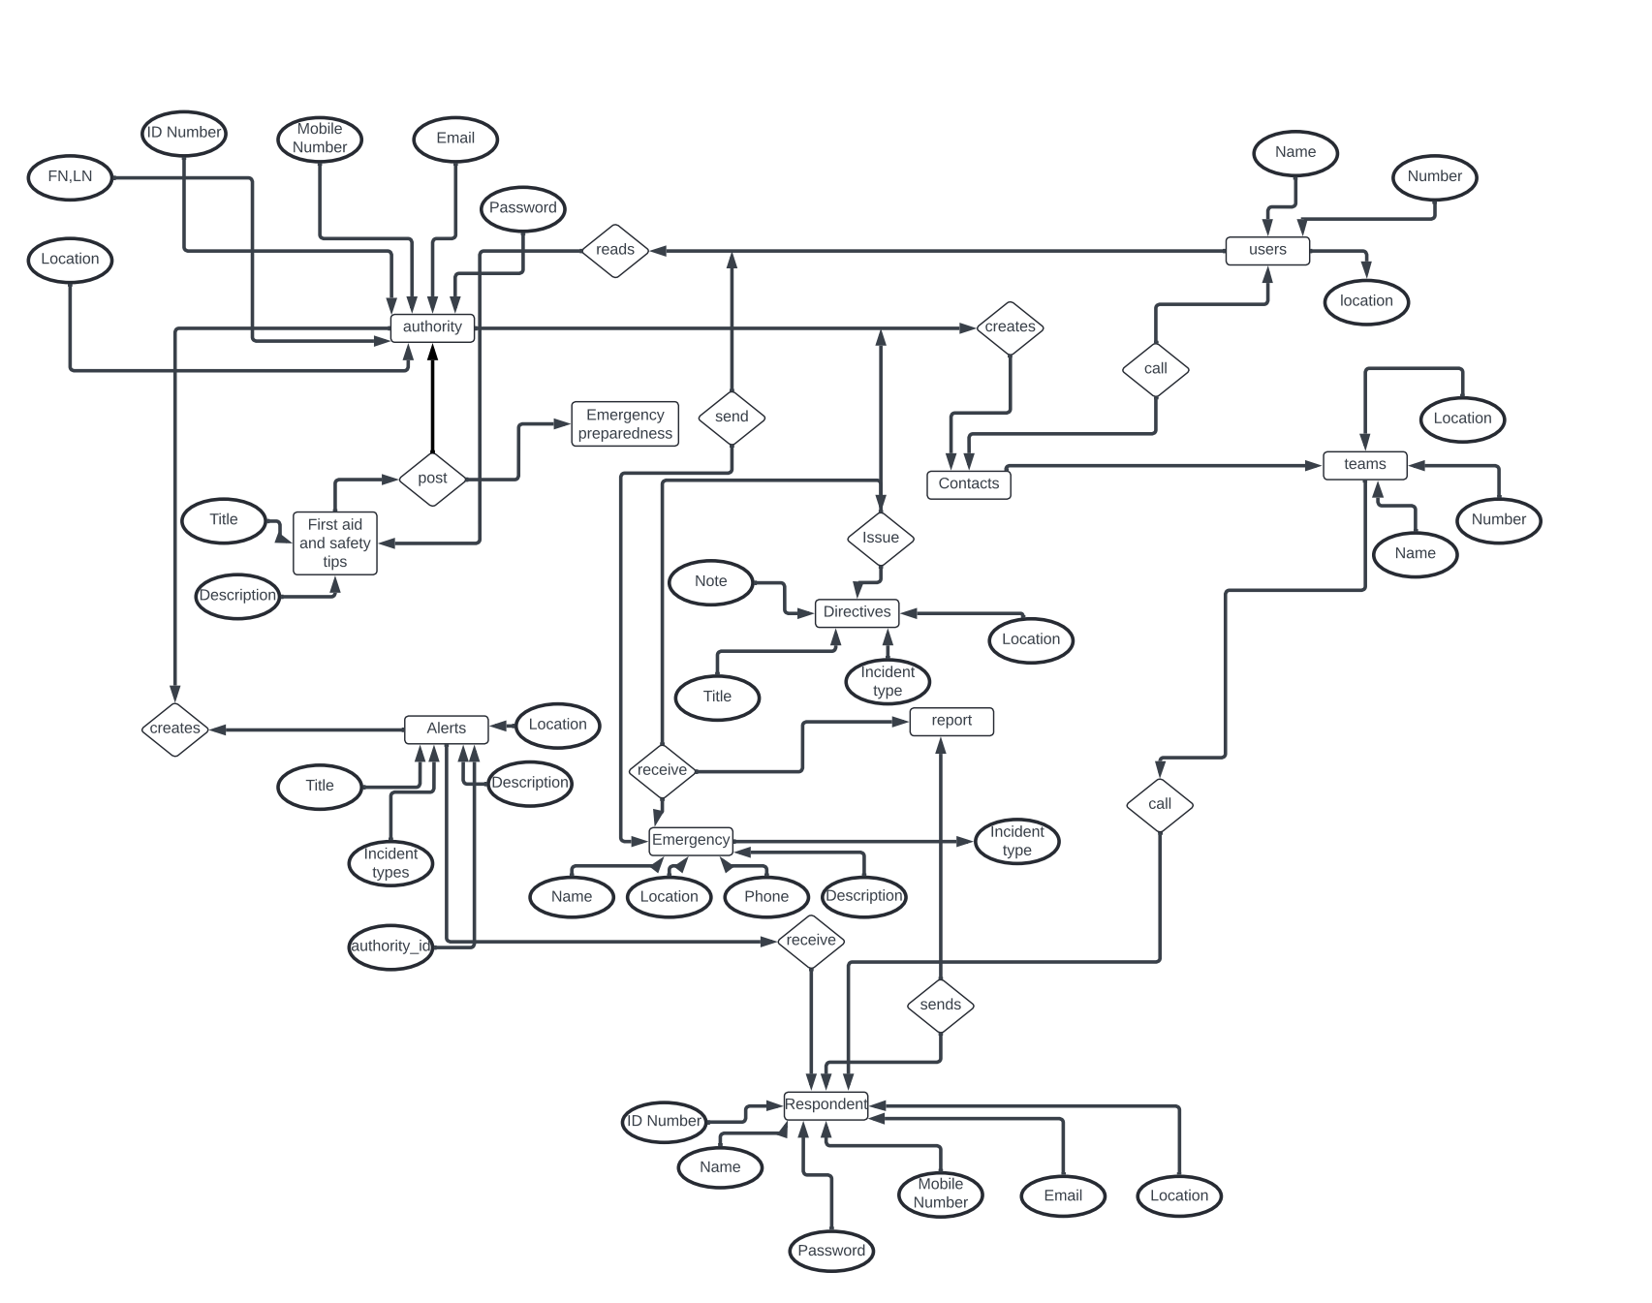

## **Key Relationships and Cardinalities:**

* + Authorities issue directives to Respondents.
  + Users send and receive Alerts and make Calls.
  + Reports are generated by Respondents and sent to Authorities.

# **3. Logical Design**

In this phase, we translated our conceptual ER diagram into a logical model, normalizing data to reduce redundancy and improve integrity:

## **Schema Definition:**

* + Created tables like Users, Authorities, Emergencies, each reflecting the system’s entities.
  + Defined attributes such as ID Number, Name, Location, and Email, using data types appropriate for the content (e.g., VARCHAR for text, INT for numerical data).
  + Established Primary Keys and Foreign Keys to maintain referential integrity across the relational database.

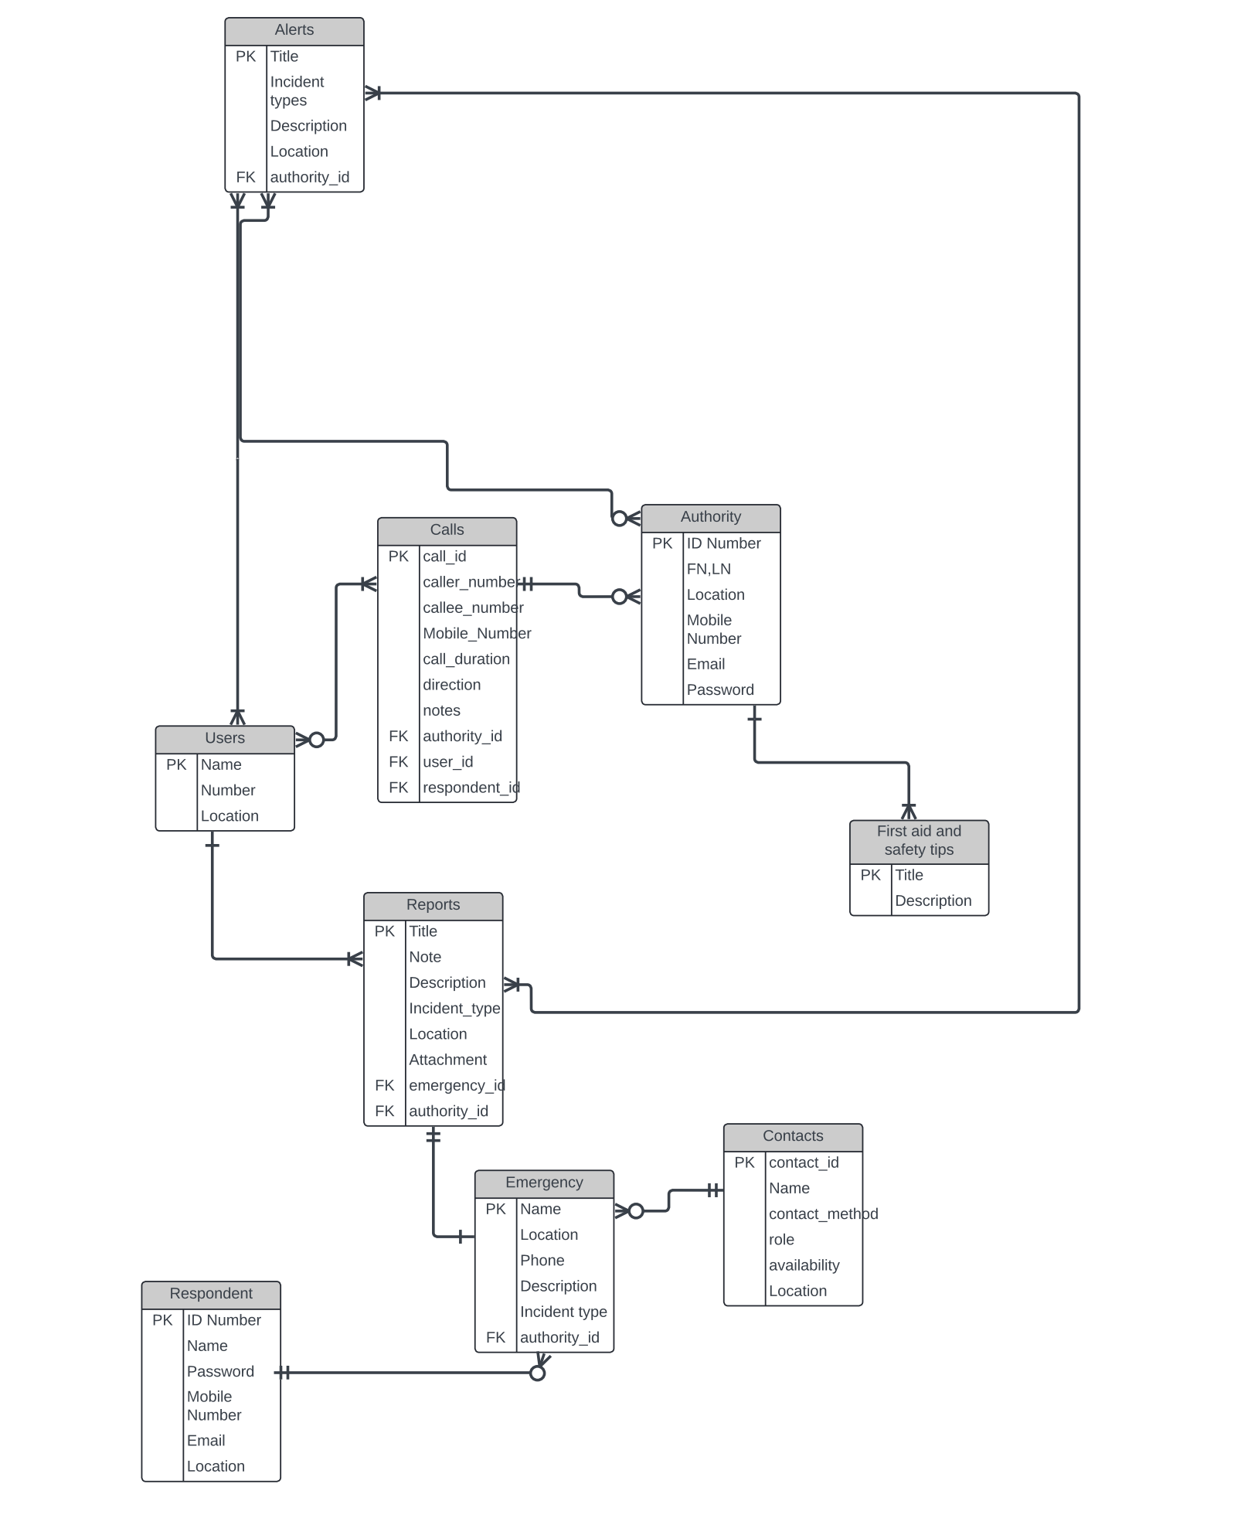

# **4. Physical Design**

We selected MYSQL workbench as our Database Management System (DBMS) due to its robustness, scalability, and support for complex queries necessary for disaster management:

## **Physical Storage Considerations:**

* + Implemented indexing on frequently accessed fields like User ID and Emergency Type to speed up queries.
  + Employed partitioning on historical data to improve performance and manageability.

## **Database Security Design:**

* + Implemented data encryption both at rest and in transit using mySQL workbench native support.
  + Setup role-based access controls to ensure that data is only accessible to authorized personnel, crucial for protecting sensitive information.

# **5. SQL Database Implementation**

Our SQL implementation phase involved the actual creation of the database schema based on our design:

## **SQL Scripts:**

* + Executed SQL scripts to create tables, define relationships, and set constraints.
  + Example SQL for creating the Users table:
  + Scripts can be found here: https://github.com/duesenberry55/CEF440-group-20/tree/main/task%206

sql

CREATE TABLE Users (

UserID INT PRIMARY KEY,

Name VARCHAR(100),

Location VARCHAR(100),

Email VARCHAR(100)

);

## **Results:**

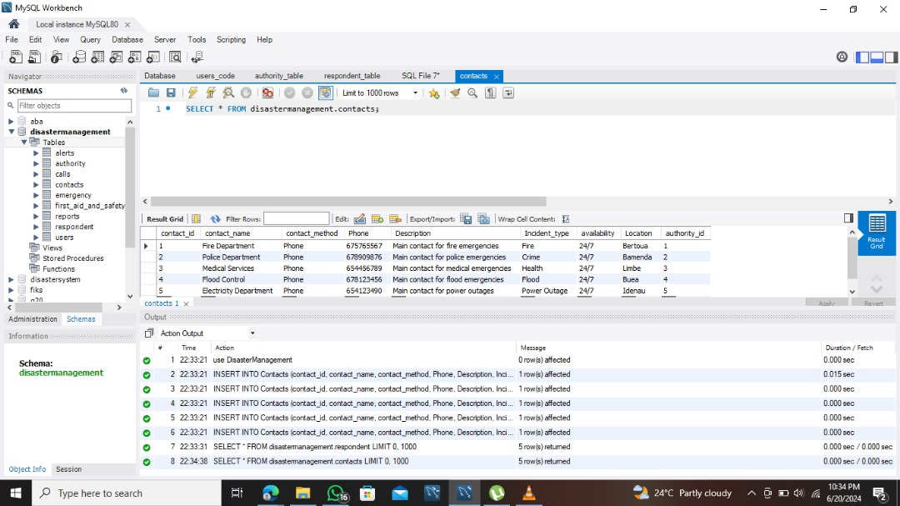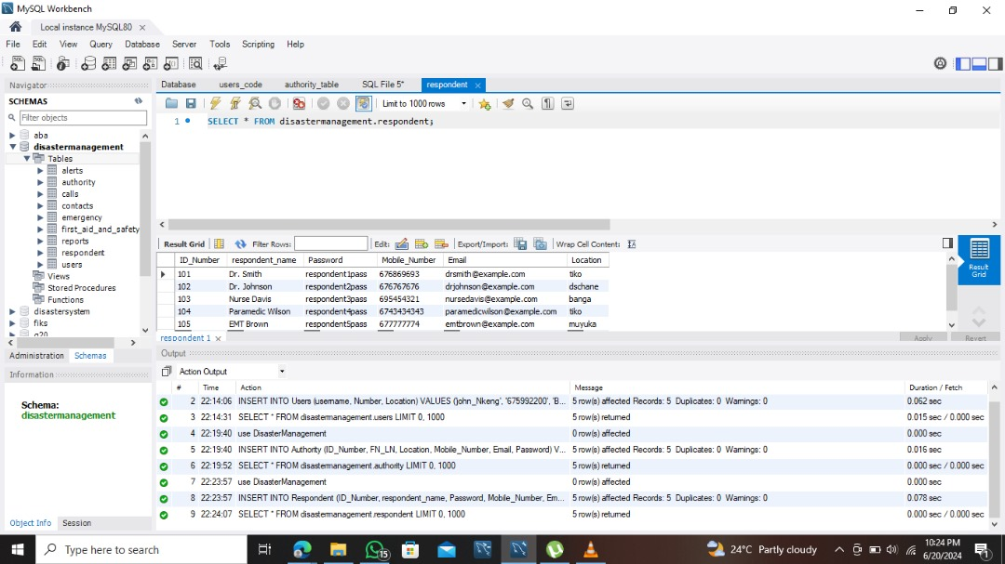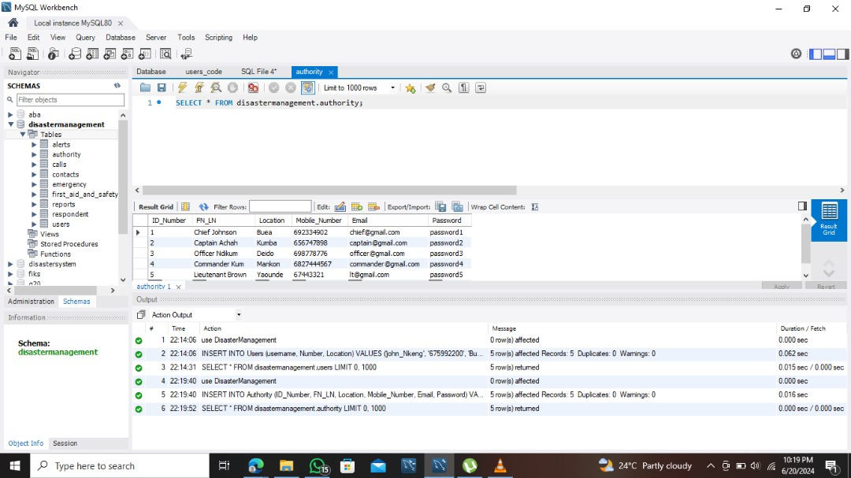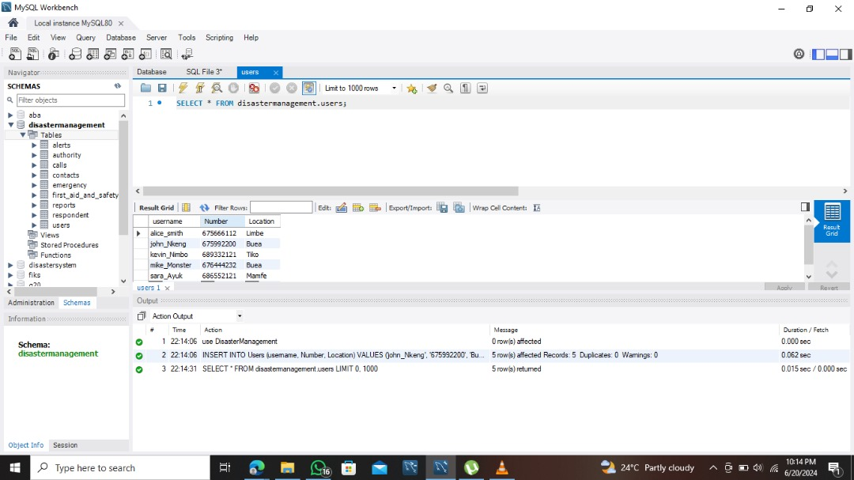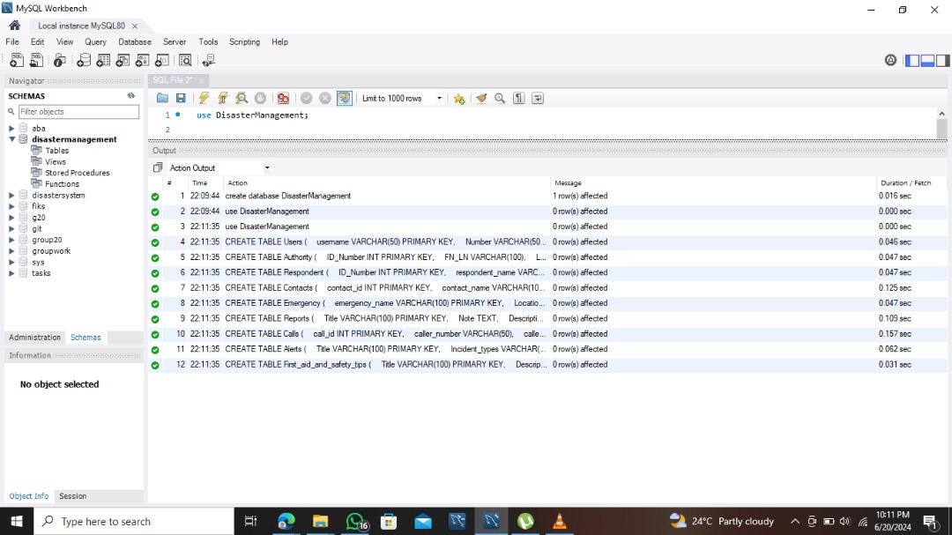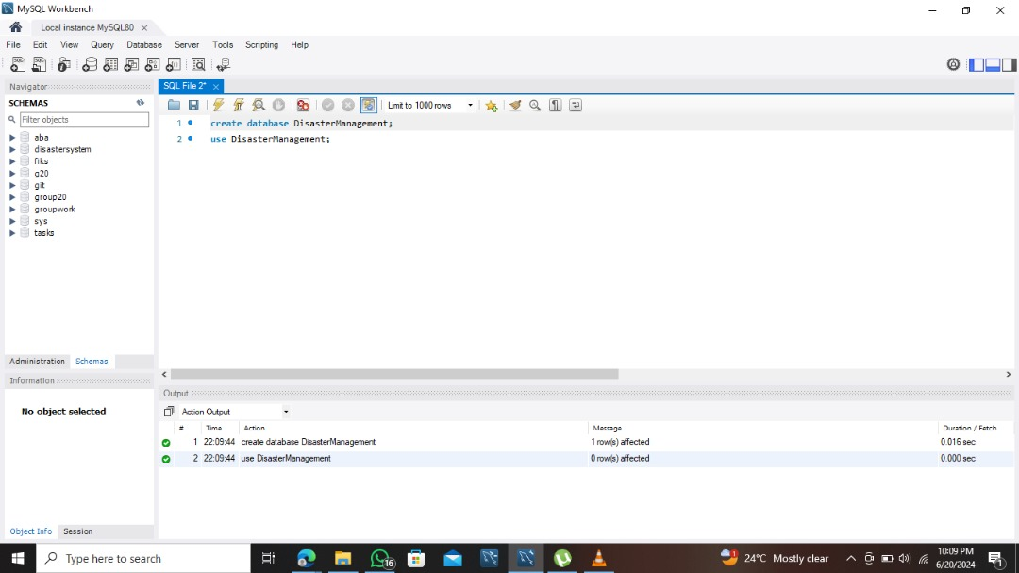

# **6. Technologies Used**

* **Database Management System (DBMS):** mySQl was chosen for its advanced features, reliability, and open-source nature.
* **Development Environment:** We utilized mySQL workbench, providing us with a graphical interface to facilitate database design and manipulation.
* **Data Modeling Tools:** Lucid chart was used to create detailed ER diagrams, supporting our data modeling and schema design processes.
* **Security Technologies:** We implemented AES encryption standards through PostgreSQL for data at rest and TLS for data in transit.
* **Testing Tools:** For load testing, we used mySQL workbench built-in benchmarking tool, to measure the system’s performance under various load conditions.

# **7. Testing and Validation**

Extensive testing was conducted to ensure the integrity and performance of the database:

## **Testing Strategies:**

* + Performed unit testing on individual tables.
  + Conducted integration testing to ensure that table relationships were properly enforced.
  + Load testing was implemented to simulate real-world usage scenarios.

# **8. Importance of Database Management in the Disaster Management System**

The structured organization of our database has significantly improved data retrieval times and accuracy, which is critical during ongoing disaster events. The system supports dynamic reporting and analysis, enabling decision-makers to quickly understand disaster impacts and coordinate appropriate responses. Additionally, the database is designed to scale, accommodating an increasing volume of disaster data and evolving management requirements.

# **9. Conclusion**

The database design and implementation phase has successfully laid down the backbone for the disaster management system. Our choices in technology and design principles have created a scalable, secure, and robust database that meets the critical demands of disaster management.

# **10. Future Considerations**

Moving forward, we will continue to enhance security measures, refine our backup and recovery procedures, and explore integration opportunities with other emergency response systems to further extend the capabilities of our disaster management system.